Instructions: Fill up the required information: name and student ID.

For multiple choice highlight the correct option.

After completing all the questions save the file and submit.

Name: Kobilov Ilkhomjon Student ID: 201923250

**Section - 1**

Multiple choice questions: Choose the correct answer. Each correct answer is worth 1 point.

1. Which one is not a component of the nucleotide?
2. Nitrogenous base
3. phosphate group
4. pentose sugar
5. amino group
6. The nitrogenous base Adenine can pair with
7. Adenine
8. Guanine
9. Cytosine
10. Thymine
11. A nucleotide in DNA is composed of
12. a ribose sugar, a phosphate, and a nitrogen base
13. a deoxyribose sugar, a phosphate, and a nitrogen base
14. a deoxyribose sugar, two phosphates, and a nitrogen base
15. a ribose sugar, a phosphate, and an amino group
16. A tripeptide has
17. 3 amino acids and 1 peptide bond
18. 3 amino acids and 2 peptide bonds
19. 3 amino acids and 3 peptide bonds
20. 3 amino acids and 4 peptide bonds
21. Which part of the amino acid gives it uniqueness?
22. Amino group
23. Carboxyl group
24. Side chain
25. None of the mentioned
26. Tertiary structure is maintained by   
    a) peptide bond b) hydrogen bond c) di-sulphide bond d) all of them
27. A mutation that does not alter the amino acid is called a ____
28. Silent mutation
29. Inversion mutation
30. Deletion mutation
31. Frameshift mutation
32. Addition or deletion of bases causes which kind of mutation?
33. Transversion
34. Frameshift Mutation
35. Translation
36. Transcription
37. Mutations produced due to treatment with a chemical or physical agent are called
38. Spontaneous Mutations
39. Inverse Mutations
40. Induced Mutations
41. Mutagen
42. Which one is not correct for Somatic mutations
43. Occurs in somatic cell
44. Sexually transmitted to the next generation
45. Observed only in asexually reproducing species
46. It is not found in reproductive cells
47. In point mutation when a nucleotide is inserted or deleted from the sequence then it is called__________
48. Missense mutation
49. Chromosome mutation
50. Frameshift mutation
51. Translocation mutation
52. DNA is made of two strands that are antiparallel. If one strand runs from 3’ to 5’ direction the other one will go from 5’ to 3’ direction. **During replication or transcription, whatever the process is, it will always follow the 5’ to 3’ direction** using the 3’ to 5’ directed strand as the template strand. Therefore, if following is the DNA sequence

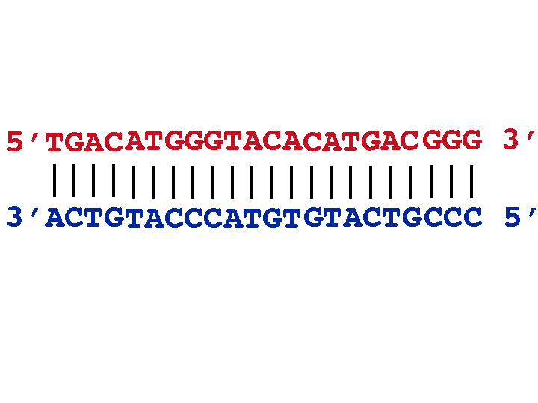

1. If the blue one is the template strand, what will be the mRNA transcript
2. 5’ TGACATGGGTACACATGACGGG 3’
3. 5’ UGACAUGGGUACACAUGACGGG 3’
4. 3’ UGACAUGGGUACACAUGACGGG 5’
5. None
6. If the RNA transcript prepared from this DNA sequence contains only EXONS, how many codons are there?
7. 4
8. 5
9. 6
10. 7
11. Each 3 nucleotides of the mRNA sequence are a codon. Use the codon table to answer the following questions:

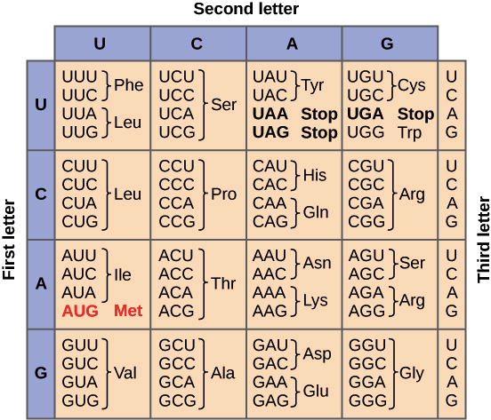

Figure: Codon Table

1. If the mRNA sequence is 5’ AUG GGU ACA CAU UGA 3’, from which codon the translation will be started? (Transcription & Translation always follows the **5’ to 3’** direction)
2. UGA
3. AUG
4. UGA
5. GGU
6. The mRNA sequence is 5’ GUG GGU ACA UGA CAU 3’, what will be the protein sequence?
7. Val-Gly-Thr-Stop
8. Val-Gly-Thr-Stop-His
9. His-Stop-Thr-Gly-Val
10. Val-Gln-Thr-Stop
11. Due to a mutation if a codon is changed to a stop codon, what type of mutation it can be?
12. Silent
13. Nonsense
14. Missense
15. conservative
16. Original: ATTTGAGCC

Mutated: ATTGAGCC. This is an example of what kind of mutation?

1. Inversion
2. Insertion-Frameshift
3. Deletion-Frameshift
4. All of them
5. A cell contains 2n chromosomes, after meiosis two types of offspring are found. One progeny contains n+1 while the other n-1 number of chromosomes. What kind of mutation is this?
6. Nondisjunction
7. Deletion
8. Conservative
9. Translocation
10. What are the major reasons for the diversity found in human

More than 2% differences in genome sequences

Single Nucleotide Polymorphism

Restriction Fragment Length Polymorphism

b & c

1. In nondisjunction mutation what happens?
2. Chromosomes separate properly during meiosis
3. Chromosomes do not separate properly during meiosis
4. Chromosomes separate properly during mitosis
5. Both (a) & (c)

Section-2

Definitions: Write the definition of the following terms. You can adjust the writing space as much as you require. Each definition is worth 2 points.

1. SNPs:

A type of polymorphism involving the variation of a single base pair is the single nucleotide Polymorphism (SNPs). Scientists investigate the association between illness, drugs and other phenotypes in the human genome with single nucleotide polymorphisms (pronounced SNPs).

1. Nonsense mutation: A mutation of nonsense is a DNA alteration that allows a protein to interrupt or end translation faster than expected. This is a particular type of mutation that induces shortened or nonfunctional protein in humans and other animals.
2. Genome:

A genome is a full series of genetic instructions for an organism. Each genome contains all the knowledge required for the growth and production of that organism.

1. Nucleotide:

The central part of nucleic acids is the nucleotide. Polymers composed of large nucleotide chains are RNA and DNA. A nucleotide is a sugar molecule bound to phosphates and a nitrogen-containing nucleus. It is either ribose in RNA or deoxyribose in DNA.

1. Missense mutation:

The new nuclear mutation shifts the codon in an unpleasant mutation, such that the protein component produces an altered amino acid. In case of a notional mutation, a codon that defines a stop codon is changed by the new nucleotide. The messenger RNA transcribed from this mutant gene would also interrupt early translation.

Section-3

Reasoning: Answer the following questions using proper logic. Each question is worth (2+4+4) 10 points. You can adjust the writing space as much as you require.

1. The mRNA sequence is

5’ AUG CCU ACG GAA CUG CUA 3’

1. Write the protein sequence that can be translated from this mRNA sequence

Answer:

Synthesis of polypeptides continues from the N-terminus to the C-terminus, and ribosomes read mRNA 5-3. In protein synthesis, three kinds of RNA molecules perform distinct but collaborative roles. In a sequence of such three letter code words, mRNA bears the genetic information copied from the DNA. A total of 64 codons are found. In these, 61 amino acid codons code, while 3 do not amino acid code. The three codons UAA, UAG and UGA are called end codons, since no amino acid is integrated when read in ribosomes. Instead the synthesis of protein stops. The synthesis of proteins starts with codon commonly known as AUG as initiator codon.

1. If the ‘G’ in 4th codon is substituted by ‘U’, what kind of point mutation will occur? Describe possible change in the protein.

Answer:

Nonsense mutation will occur, the altered DNA sequence, however, prematurely signals the cell to avoid creating a protein, rather than replacing one amino acid with another. This will result that protein might not function properly or not at all.

1. If a new nucleotide is inserted before ‘U’ at the 2nd codon, what kind of mutation will occur. Describe why this kind of mutation is much severe by mentioning the possible outcome in the protein structure.

Answer:

Deletion mutation.

1. Below is a comparison of 50 kb of Yeast, Drosophila and Human gene sequence. Blue bars represent exons while light green bars represent introns.

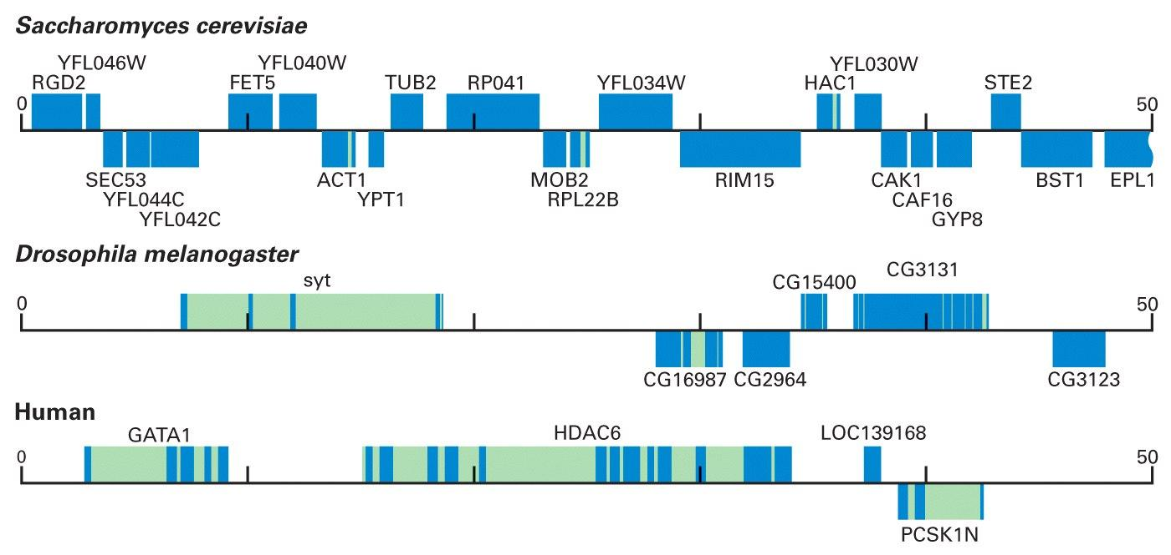

1. Define exon and intron.

Answer:

1. Humans are the most complex organism among these species yet it contains the least amount of exons. Explain how?

Answer:

1. If one or more introns are retained in the RNA sequence during mRNA preparation, what would happen? Explain briefly.

Answer:

In an open reading frame or frameshift, the retained introns can add a stop codon, which can lead to gene expression control through the premature translation termination without altering transcription activities.